Stored Procedure- In pega database uses stored procedures to ensure database integrity and consistency. They begin with the prefix SPRC_

So first we need to create a stored procedure and since pega uses pgsql we need to create a stored procedure and then we need to call and see the call is successful and then we need to get the result

Queries used in pgSql

For creation of tablre

CREATE TABLE public.testing(demo_column text);

And then for the creation of procedure

CREATE OR REPLACE PROCEDURE public.testing_procedure()

LANGUAGE "plpgsql"

AS $BODY$

DECLARE

v_msg text;

BEGIN

v_msg := 'Hello Subbu';

Insert into public.testing(demo_column) values (v_msg);

END;

$BODY$;

And then for the calling of the procedure

call public.testing_procedure();

and then select the rows in the stored procedure

call public.testing_procedure();

and now through activity

use RDB-Open to open the rule or to show the rule and in the CONNECT-SQL rule also paste the same syntax which we are using for the call

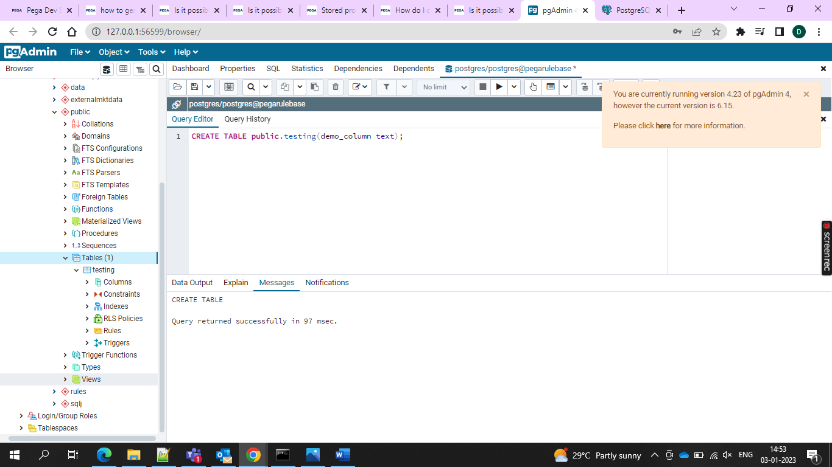

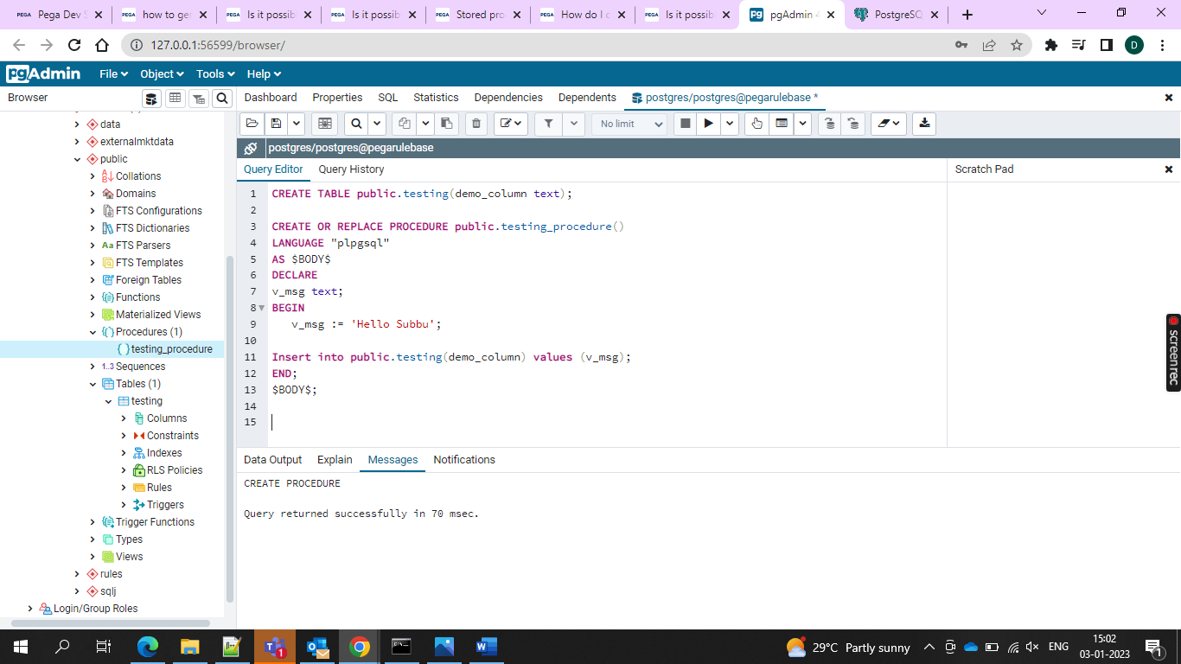



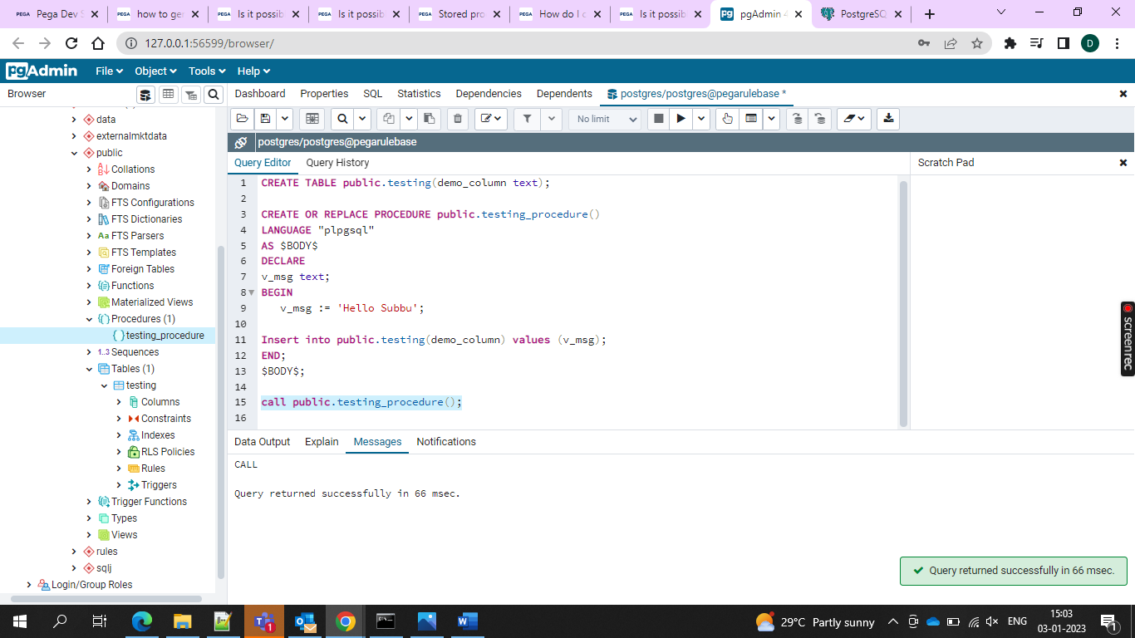

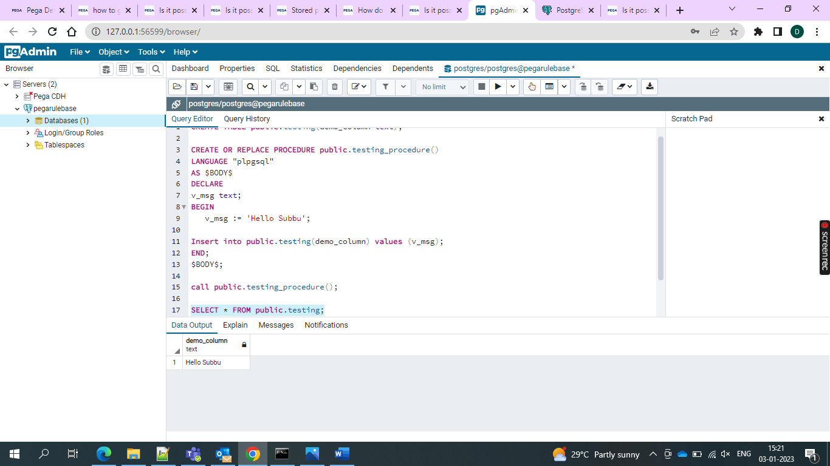

And now use an activity to call or invoke it a new record is created.

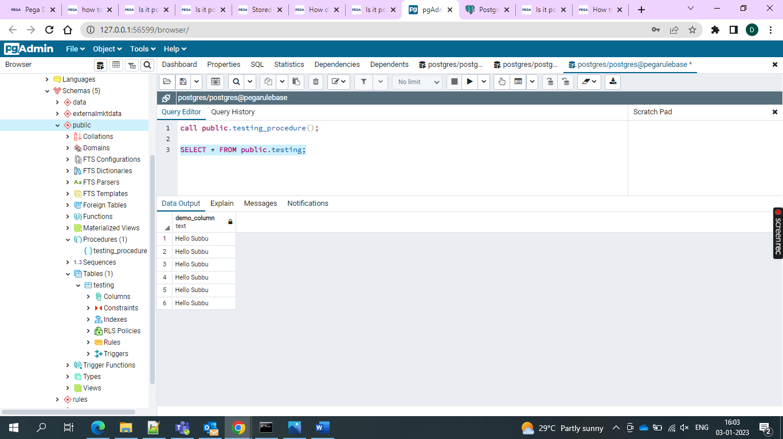

So new records are there in the stored procedure